Volume XXXI Number 5 May, 2021
 | SSSF Facebook Page |  | 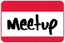  SSSF Meet–Up Page | Sailing Singles of South Florida  Website  P. O. Box 4532,  Fort Lauderdale, FL 33338
 | Upcoming Events | June 4 - General Meeting - Stingers June 10 - Social - Galuppi’s  June 17 - Social - Galuppi’s June 24 - Social - Galuppi’s  June 28 - Board Meeting - TBD
Schedule of Events
Upcoming Events:
June 4 - General Meeting - Stingers
June 10 - Social - Galuppi’s
June 12 - Day Sail - Come Sail Away
June 17 - Social - Galuppi’s
June 24 - Social - Galuppi’s
June 26 - Marlins Game
June 28 – Board Meeting – TBD
July 3 – 4th of July Celebration at Arlene’s House
July 4 – Raft up Biscayne bay
Promote your business with our Business Card ads.
Starlight Musicals every Friday Night
Holiday Park in Fort Lauderdale

Join us for the Starlight Musicals every Friday evening beginning June 11,2021 thru August 19.
This concert series is held at Holiday Park in Fort Lauderdale every Friday evening over the summer.
Sailing Singles members are invited to attend along with Guests at no charge.
Parking is Free! Bring a dish to share and a beach chair.
Look for Jean Deering’s tent (SSSF member) and Andy Deering at the back of the field. Get there at 6:30 pm as the concerts start at 7:00 pm.
Holiday Park is located at the corner of Sunrise Blvd. and Federal Hwy. behind War Memorial.

Hope to see you there!!!
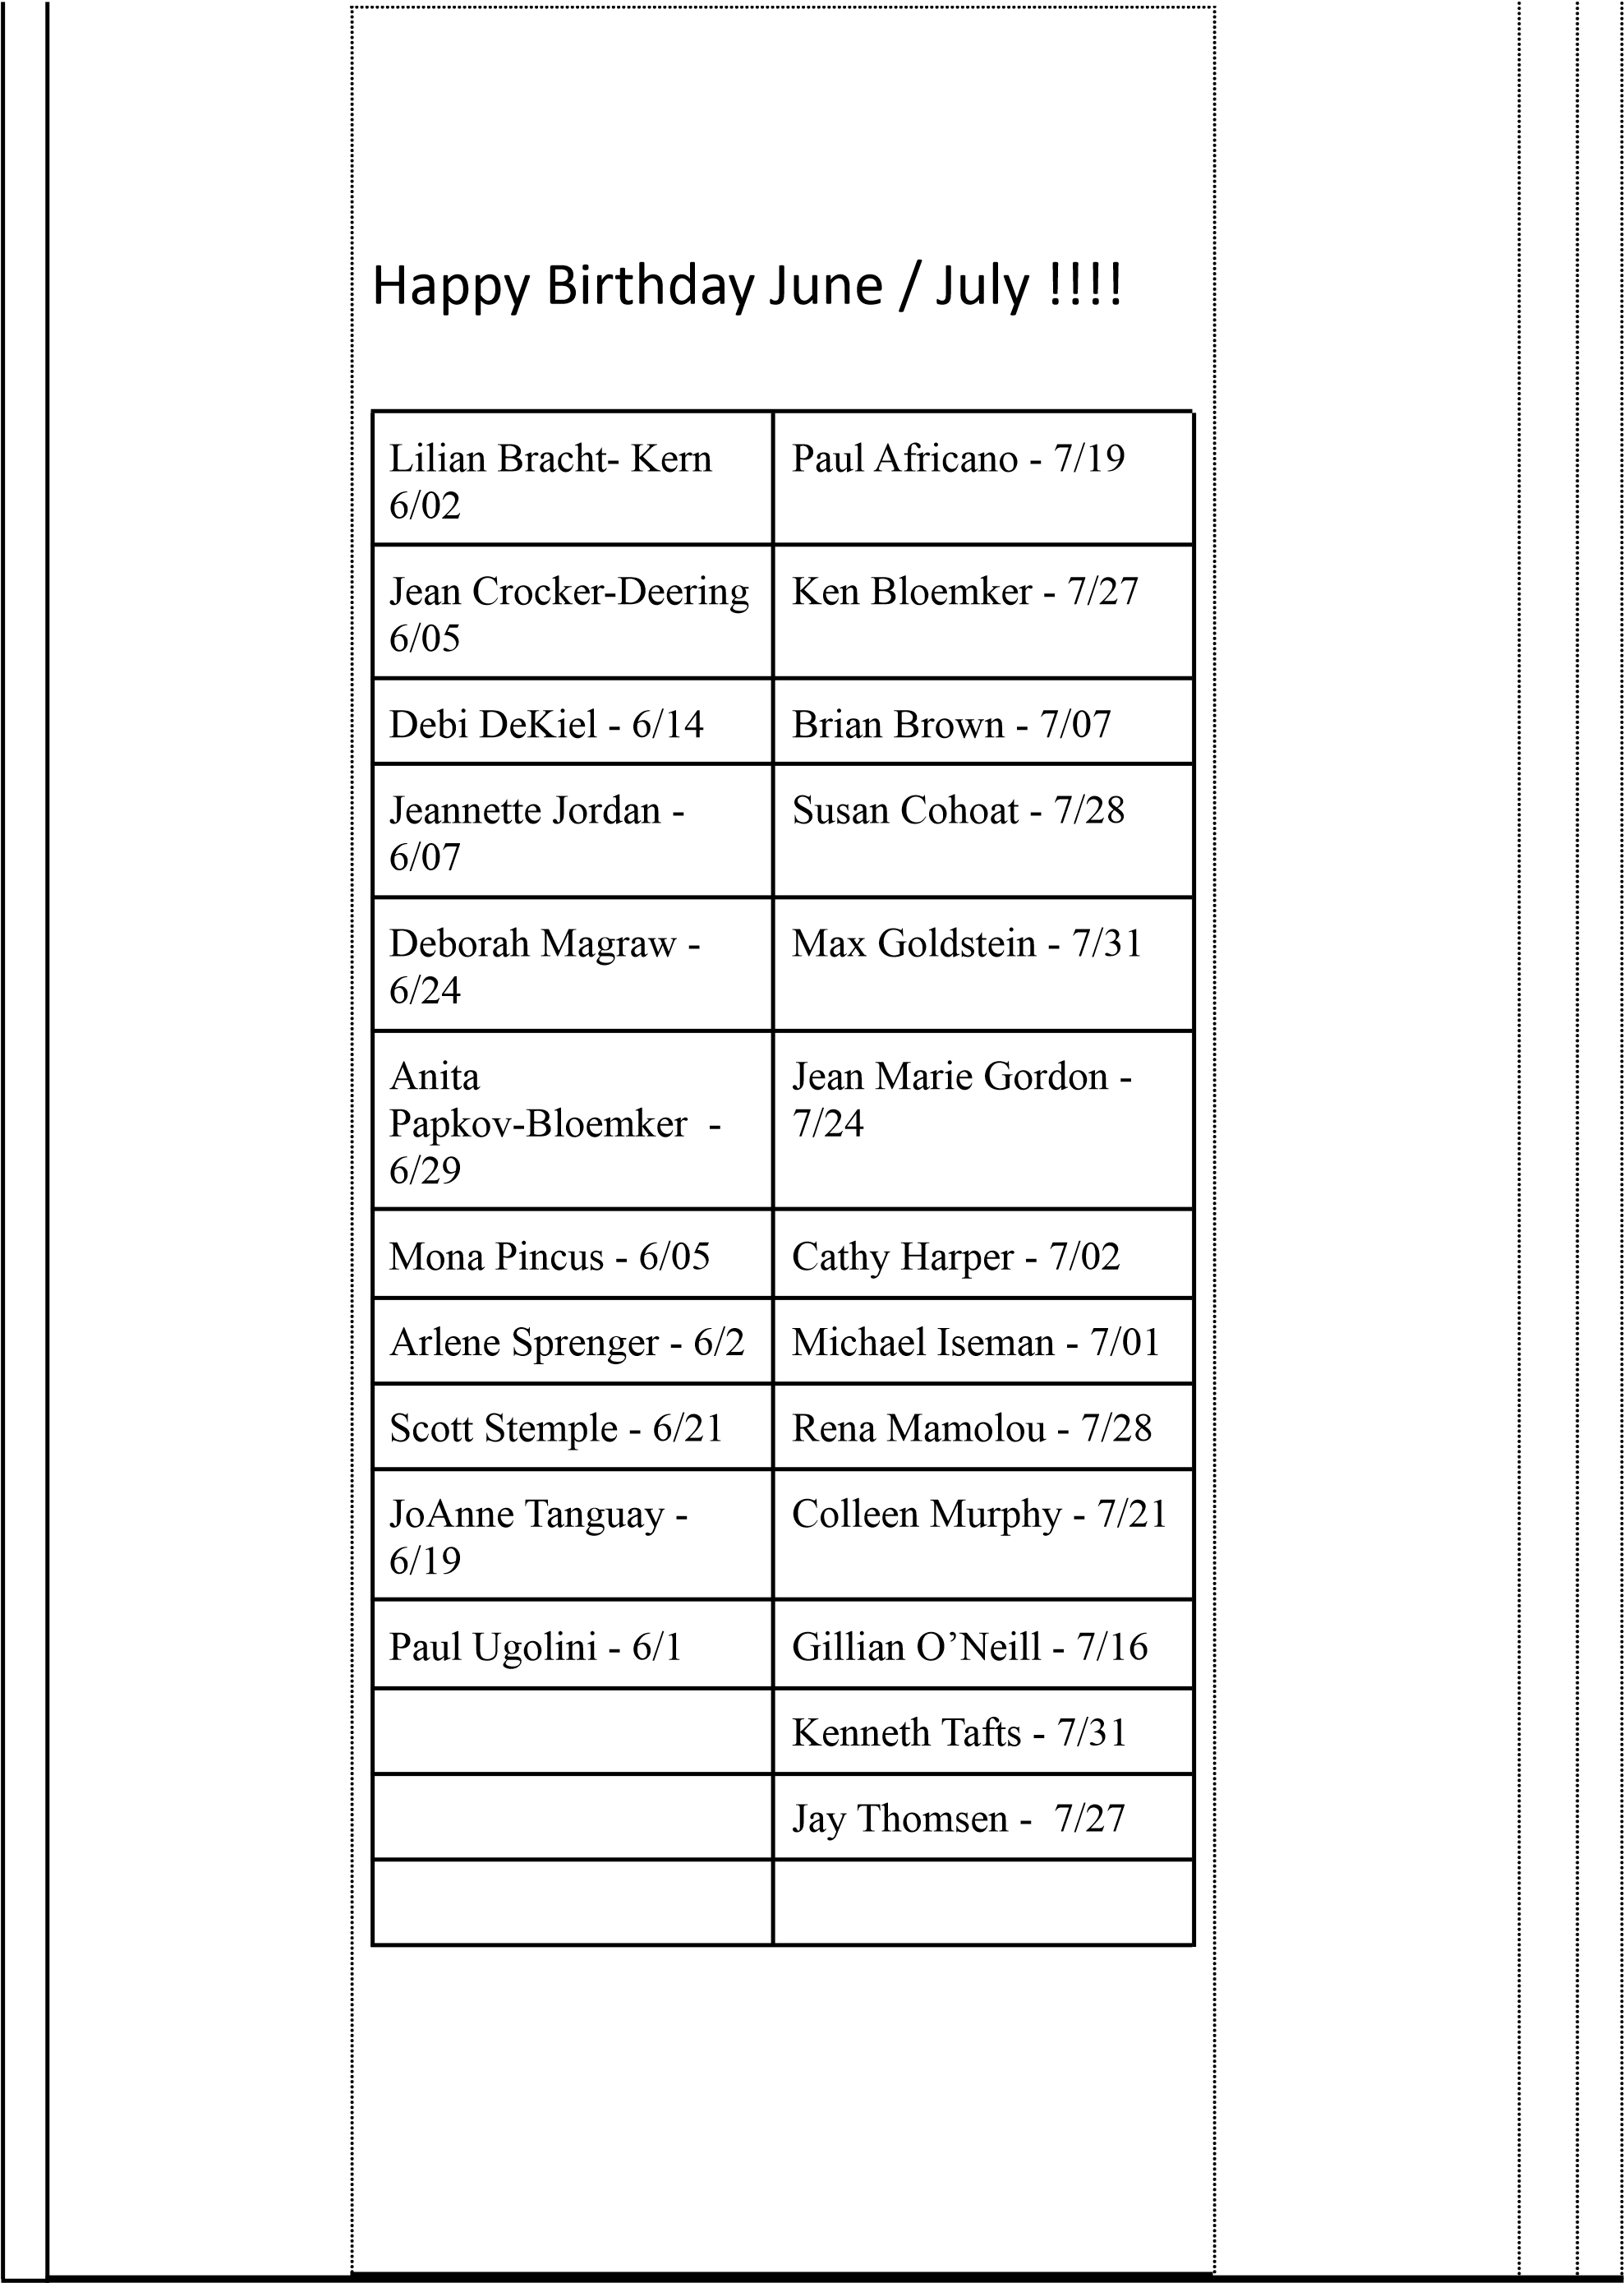
From The Helm
This month’s issue of “From the Helm” will be short only because I’d like to honor John Konheim.

We will all miss him. Personally I’m really mad at him because he said he did amazing teak work and we’d made a date when he could come to my new-old boat to work on my hand-rails. Old guys like us like to work on other old guy’s boats. That’s part of our Club connection and there’s a deep vein of that love and support throughout the boaters in our Club. We help each other.

Well …John was part of that connection.

So..I am sure John would like us to remember him as he was. And with that I will tell you a story from the Hillsboro Circle raft up a couple years ago. Many of us went to that raftup from SSSF. John arrived a little after they had called off “making the circle” because of high winds. The winds were decidedly strong – 15-20. If a gust caught you and you were not in control of your boat every second, things happened.

My recollection of the event…John comes into our rafting area then loses helm control because of the harsh winds. Then his electric motors have little prop speed so he can’t “pull away” so easily. What ends up happening is John can maintain helm control going backwards but not frontwards. (I’ll ask our Club Members why?)
All the while he’s bumping into a few boats here and there and nobody is getting mad at him.
Everybody is trying to help. Well….
Come to the RESCUE..Capt. Kelly (in his animal print leggings) dives into the water, swims over to Johns boat and then successfully anchor’s John’s boat without further incident. Everyone on John’s boat lets out a big sigh of relief! Captain Kelly did a mitzvah for his fried; all part of our Club connection.

And with that my friends… I hope you are all well and happy. More news to follow on another day. We’ve got a lot of things going.

Captain Brian
Commodore

July 3 Pool Party!!!

Celebrate the 4th with food, fun and swimming!
Location is Arlene Sprenger’s house!
1415 SW Street, Fort Lauderdale 33315

Bring your bathing suit, towel and a dish to share. (BYOB)
Hot dogs and Hamburgers and Water will be provided by the club.
Parking is adjacent in empty lot west of Arlene’s home.
Cost: $5.00 Members $10.00 Guests
Dish to share suggestions if your last name begins with
( A-G salad, H-M Side dish, N-S Appetizer, T-Z Dessert )
Questions call Arlene (954-566-0008)
RSVP Required ON CLUB WEBSITE
Registration required go to www.sailingsingles.org.

Watch for more info on our Circle of LOVE raft up scheduled for August 7- 8 at Lake Boca!

Welcome the SSSF 2021 Board of Directors

Commodore: Brian Brown  Vice Commodore: Elyse Greene  Secretary: Iris Voorhees  Treasurer: Nancy Widener  Membership: Carol Rapport | Newsletter: Linda Cusmano  Social Chair: Arlene Sprenger  Sailing Director: Rich Luce  Fleet Captain: Kelly Dobbs  InformationTechnology:Cheryl Lutz

